**Add Links to Blog**

**Send Feedback**

We now know how to jump from one page to another.

Isn't this interesting! And remember, links can be used together with a lot of other tags.

So, let's add some links to your blog page. The element with the links to are provided below -

1. ELEMENT - <img src="https://ninjasfiles.s3.amazonaws.com/0000000000001394.png" alt="coding ninjas logo">

LINK TO ADD - http://blog.codingninjas.in/

2. ELEMENT - <img src="https://ninjasfiles.s3.amazonaws.com/0000000000001395.png" alt="coding ninjas love coding">

LINK TO ADD - http://blog.codingninjas.in/

3. ELEMENT - <p>blog.codingninjas.in</p>

LINK TO ADD - http://blog.codingninjas.in/

**The blog page will look like the image below -**

[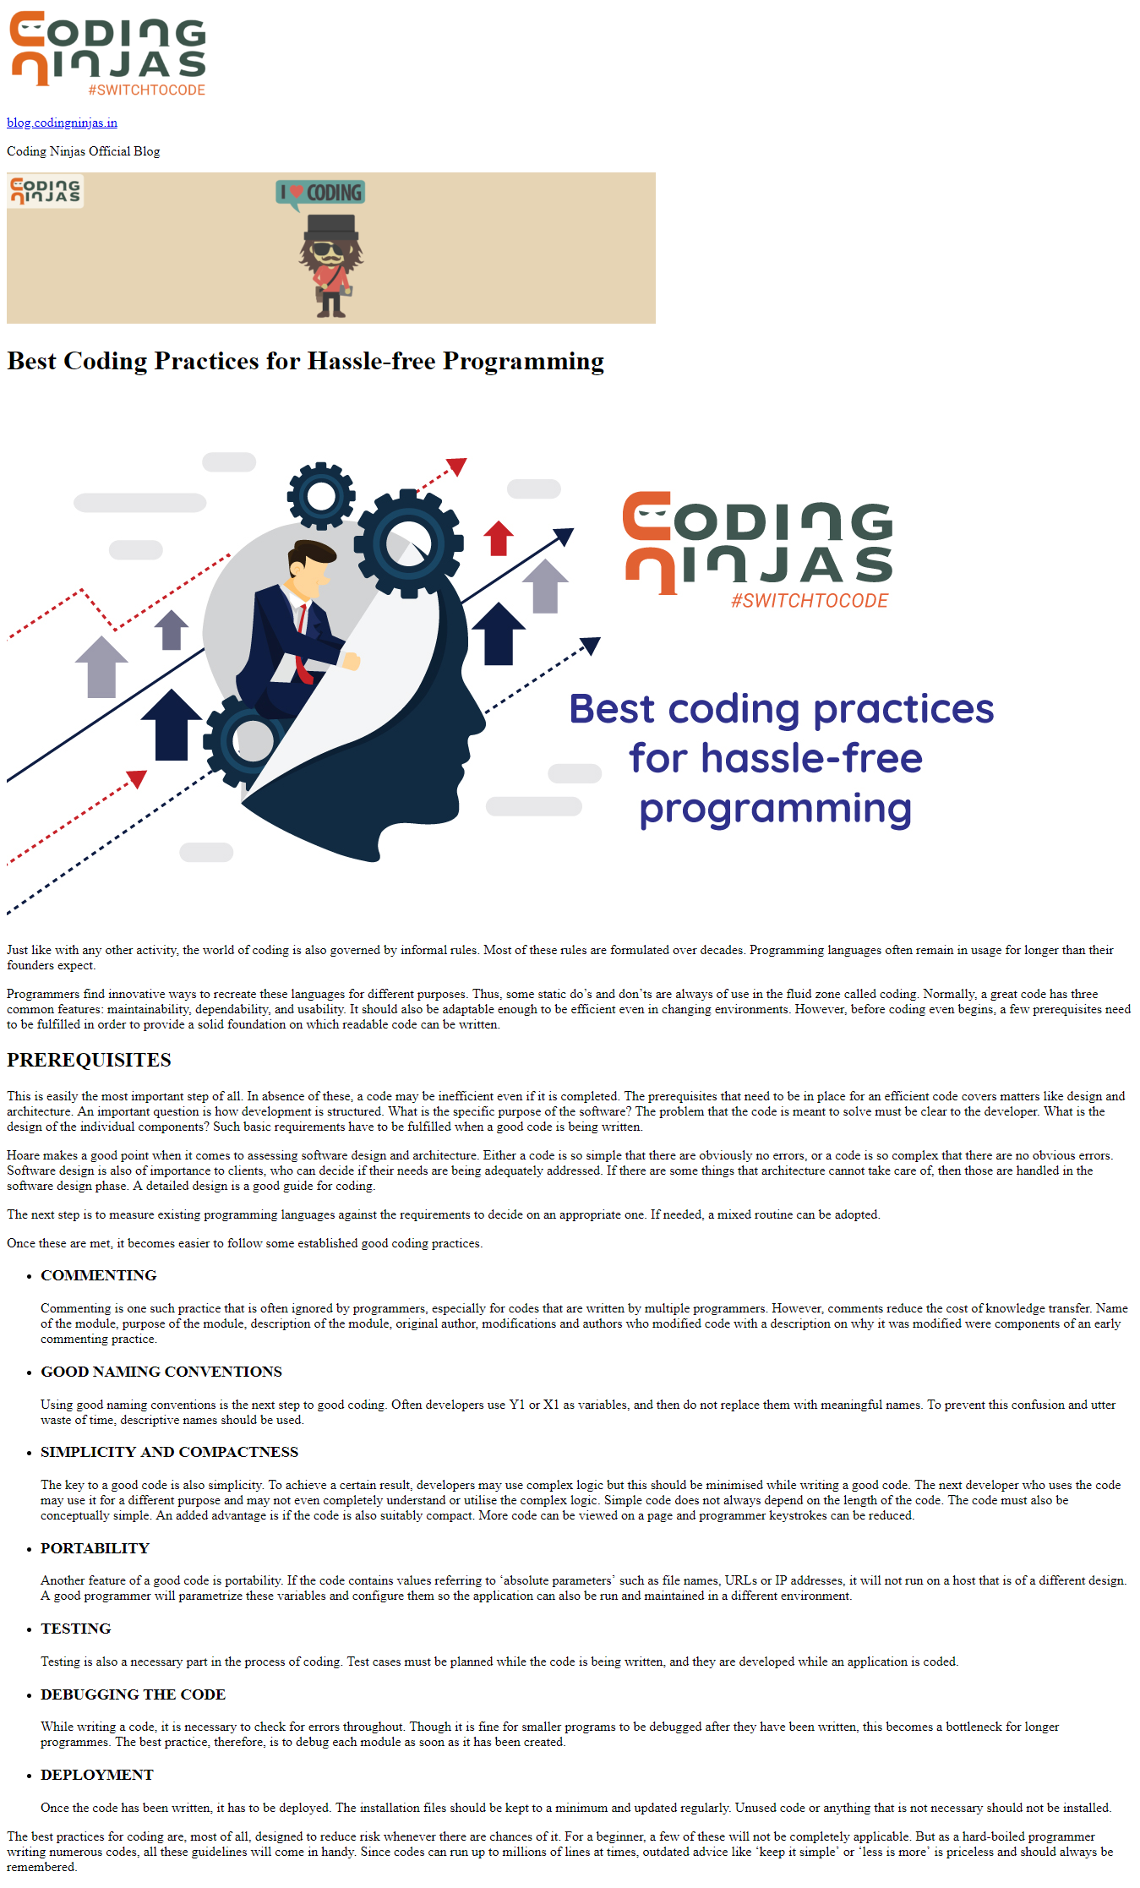](https://ninjasfiles.s3.amazonaws.com/0000000000001400.png)